Research Type (Original Article/Case Study/Review Article)

PAPER TITLE IN ENGLISH (mandatory) (14pt Times New Roman/Cambria)
Sub Title - If any

Author(s) (correspondence)* (11pt Times New Roman/Cambria)

Details: (11pt Times New Roman/Cambria, Left) (English mandatory)
First Name:
Middle Name (If any):
Last Name:
Affiliation: Designation, Department, College/University, city, (state), Country
Email Id:
ORCID Id: If available, the 16-digit ORCID of the author(s) (it’s free you can create from link : https://orcid.org/)
Abstract English (mandatory) (11pt Times New Roman/Cambria)
Each article should be accompanied by an abstract of up to 250 words in English, which should mention all the principal facts and conclusions set forth in the paper. A similar abstract in Hindi language may be added, but this is not required.

Keywords English (mandatory) (11pt Times New Roman/Cambria)
Write here minimum Three (3) keywords relevant to the research presented in the manuscript.

(The complete manuscript content can be in English language).
- For English font must be (11pt Times New Roman/Cambria)

Use below format for heading and sub heading.

HEADING 1

SUB HEADING 2

SUB HEADING 3
Paragraph: use this for the first paragraph in a section, or to continue after an extract.
New paragraph: use this style when you need to begin a new paragraph.
- For bulleted lists
- For numbered lists
Displayed equation (1)

GUIDELINES FOR TABLES AND FIGURES
- Do not restate all the information from tables/figures in the text of the paper -Tables/figures should not be used to highlight what has already been said in the paper
- Tables or graphs?
  - Use tables to present detailed, important data
  - Use graphs to show trends in data
- A common and simple table format is used in most of the tables on these pages. It includes a thin straight border under the title and heading cells and under the main body of data. There is usually no need for vertical borders. Often, the title is in bold. Putting the headings in bold is advised only if they are very short headings, and not if it is inconsistent with the format for other tables in the report.
- Refer to all the tables/figures in the text
  - Point out the relevant part(s) of a table/figure when referring to it
  - Refer to tables/figures with their numbers (e.g., Table 1); do not refer to their location (like “in the table below”)
TABLES
- Use tables to present data that is detailed and that is important
- Tables are “expensive” in terms of space requirements and formatting demands
- Each table needs a concise title of no more than one sentence, placed above the table with the table number. The legend and footnotes should be placed below the table. Footnotes may be used to explain abbreviations.
- Consider using text instead of tables if data is:
  - Not detailed: One or two sentences can be used to describe the data
- Not important: The entire data does not need to be presented; instead, a summary can be given in text.
Sample of a “Table”

Table 1: Tests of Normality for age, body mass index, level of education and level of happiness
Variable | Kolmogorov-Smirnovª |  |  | Shapiro-Wilk
 | Statistic | df | Sig. | Statistic | df | Sig.
Age | .120 | 120 | .000 | .942 | 120 | .000
Body Mass Index | .161 | 120 | .000 | .936 | 120 | .000
Level of education (in years) | .204 | 120 | .000 | .940 | 120 | .000
Source: If any

FIGURES
- Clarity: Make sure that all the parts of the figure are clear and legible at the figure size you have used.
- Figure number and title appear below the figure.
- Completeness:
  - Label the important parts of schematic diagrams
  - Insert scale in images and maps

ACKNOWLEDGEMENTS
People who contributed to the work but do not fit criteria for authorship should be listed in the Acknowledgments, along with their contributions. It is advised that authors ensure that anyone named in the acknowledgments agrees to being so named. Funding sources that have supported the work should also be cited.

FUNDING
Please provide funding details if any.

APPENDICES (if applicable)

A writer places in the appendices additional information that supports or illustrates points in the paper. Items in the appendices allow the reader to go deeper or gain a clearer view of what is being said in the main text.
Appendices are important but they are not a “dumping ground.” For example, not all data goes in the appendices; however, a log of data sets may be appropriate. Not all student work would be placed in the appendices, but a sample that clarifies an assignment would be appropriate. List each appendix as “APPENDIX A,” “APPENDIX B,” etc.
Possible inclusions in the appendices include:
- a log of data sets or specific items from a data set;
- assessments;
- surveys, questionnaires, and interview questions;
- letters home (including how you gained permissions);
- lesson plans;
- artifacts.

REFERENCES (English) (mandatory) (11pt Times New Roman/Cambria)
All references used for the study should be cited in accordance with APA style https://apastyle.apa.org/style-grammar-guidelines/references/examples.

The parenthetical citation must be given in content (you can give number with correspondence to the reference number in square bracket like [1]).

Plagiarism is not only legally and ethically wrong; it cheapens the quality of your journey.

Some examples of APA style citation given below, more examples can be find on above link↓

- Journal Article References

- Book/Ebook References

- Webpage on a Website References
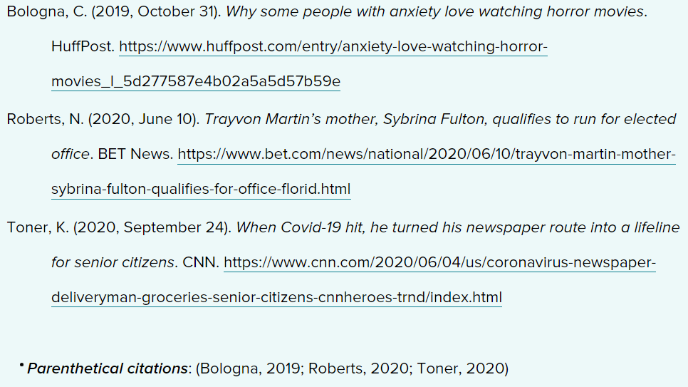

- Wikipedia Entry References

- Conference Proceeding References
- Chapter in an Edited Book/Ebook References

- Blog Post and Blog Comment References

- Newspaper Article References
